

CSF 3233: Antara Muka Laman Web

Lab Report 3
Name: CHONG YU
Matric No.: S76136
Group: K4
Program:
Computer Science (Software Engineering)

Activity 3.2
Code:
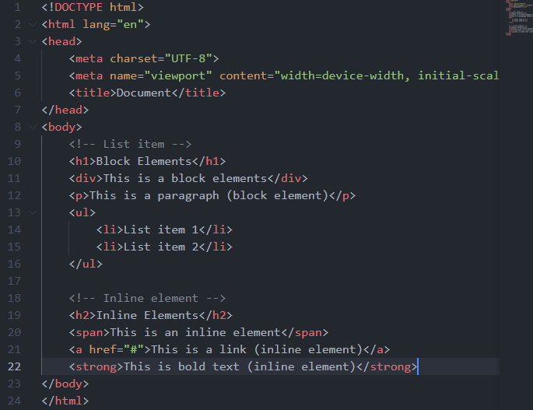

Output:
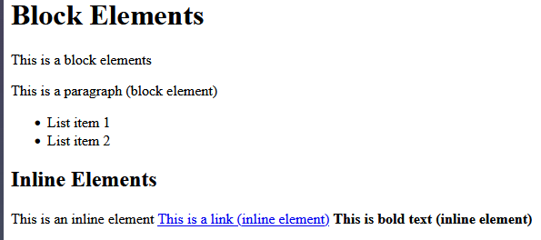

Activity 3.3
Code: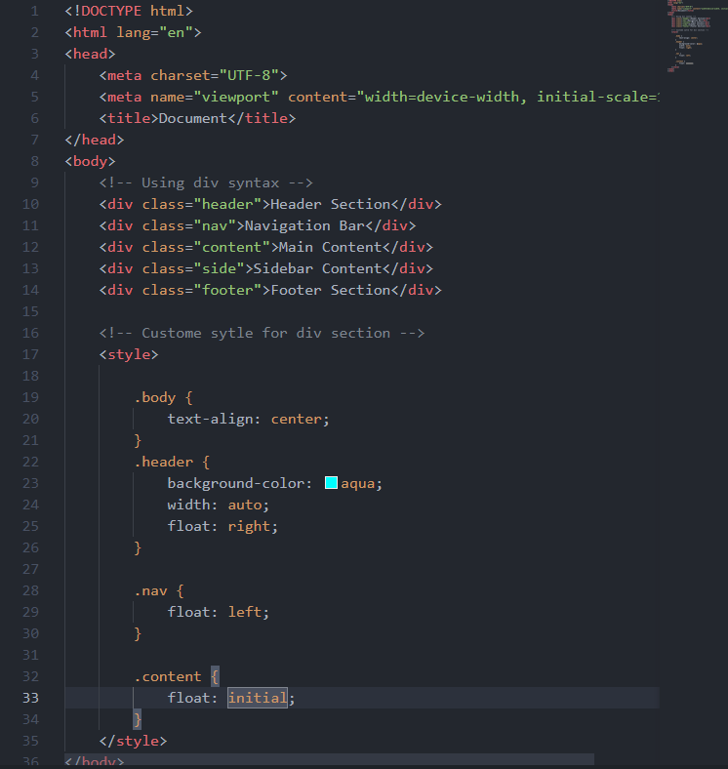
Output:
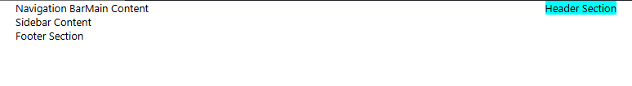

Activity 3.4

Code:
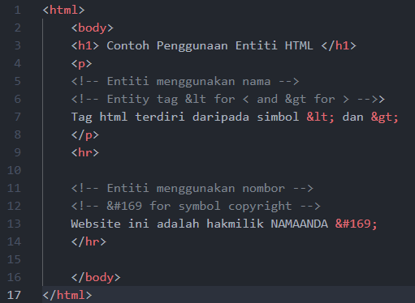

Output:
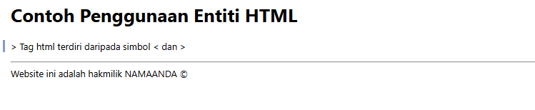

HTML Entities:
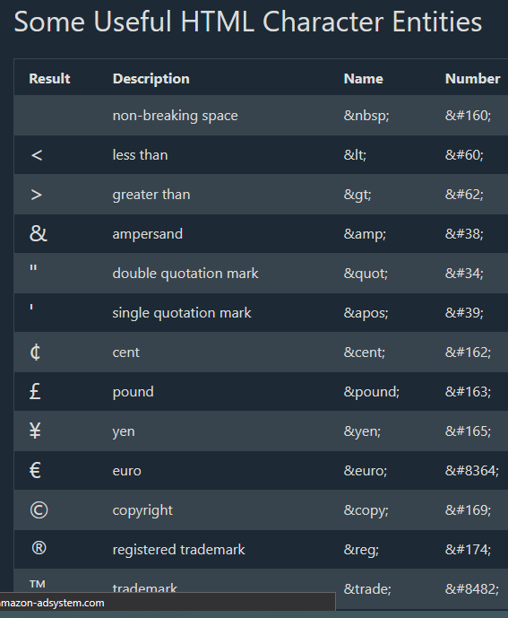

Activity 3.5
Code：
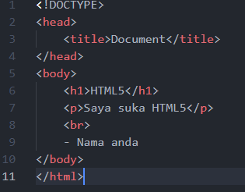
Output for validator:
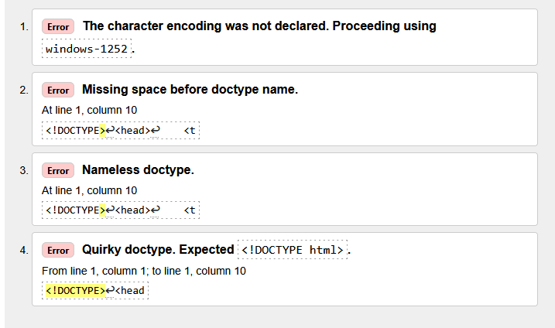
Answer:
The output showing got a few errors in the file that has been sent. In the code, after !DOCTYPE missing html tag that state the document type for the web page.

Activity 3.6.1
Code:
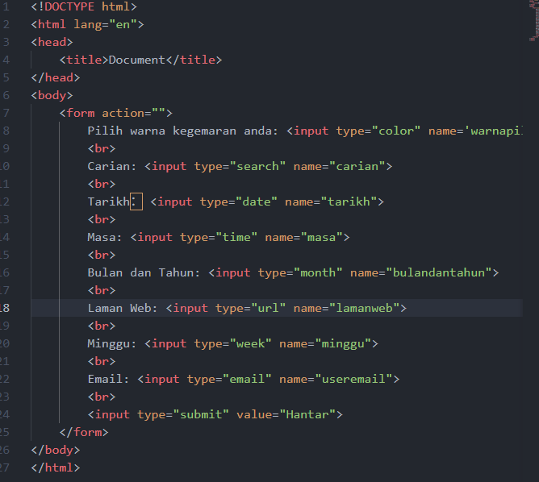
Output:
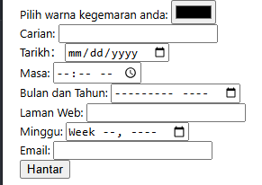

After clicking the Hantar button
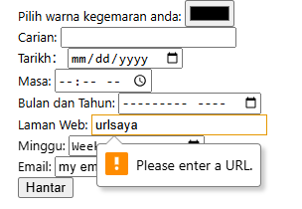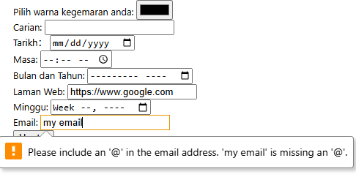
The format for the link is correct so that the form will ask user to input again for a new URL link. For the email also the same, the email address format are incorrect.

Activity 3.6.2
Code:
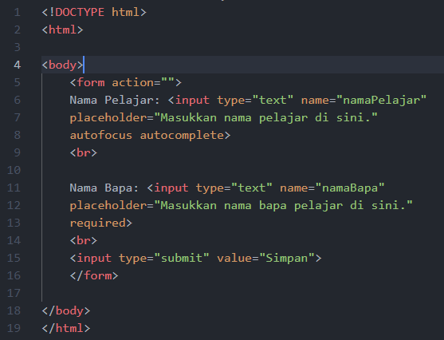
Output:
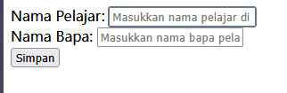
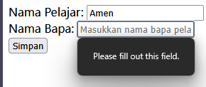

Answer:
The cursor will first focus on the input field for Nama Pelajar, this is the result using the tag autofocus. The required tag will be showing some text that reminds user to fill in some value for the specific input field. The autocomplete syntax did not work fine during the time working on this lab report.

Activity 3.6.3
Code: 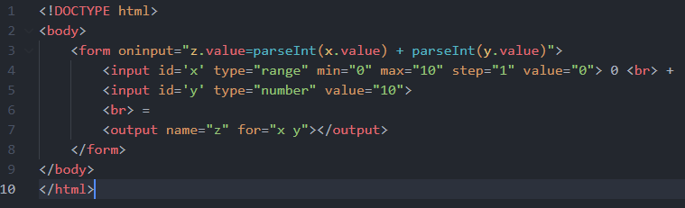
Output:
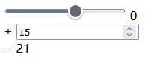

Lab exercise:
Code:
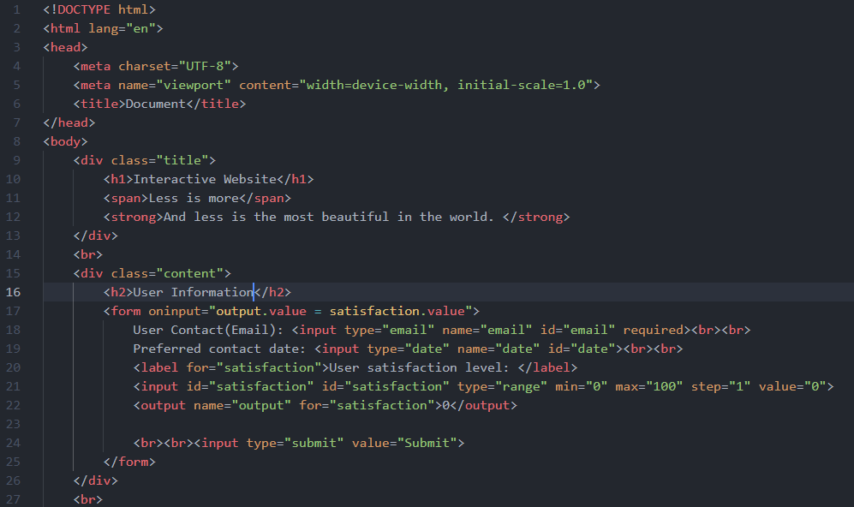
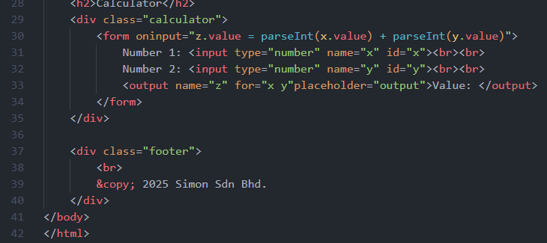

Output:
